Woodsmoke Reduction Program
VOUCHER APPLICATION PACKET
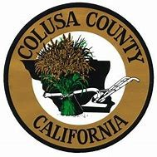

HOW THE VOUCHER PROGRAM WORKS
1. The Air Quality Management Districts and Air Pollution Control Districts (Districts) of Butte, Colusa, Glenn, Nevada, Plumas, Shasta, Sutter, Tehama, and Yuba counties are offering vouchers to replace non-EPA certified woodstoves, fireplace inserts, or open-hearth fireplaces used as a primary source of heat with new, cleaner burning devices. The new device may be an EPA certified catalytic wood, hybrid, or pellet stove, an electric or an electric heat pump. Select non-catalytic wood stoves are also eligible.
Applications for rebate vouchers will be accepted until project dollars are depleted. Please include a photo of the currently installed older stove, fireplace insert, or fireplace. The completed applications must be signed by the homeowner (and tenant if applicable) and submitted to the District of the county in which the device is located.
2. The Standard Voucher is valued at 2,500 for new pellet, wood-burning, and electric stove devices or $5,000 for new electric heat pump installations. Please be aware that the Standard Voucher amount will not cover the entire cost of the new EPA device, installation, required permits and any code upgrades that may be required.
3. The Enhanced Voucher is valued at up to $5,000 for new pellet, wood-burning, and electric stove devices or $10,000 for new electric heat pump installations. Applicants are eligible for an Enhanced Voucher if the project is in a Low Income or Disadvantaged Community¹ or if the applicant participates in a Low Income program (WIC, CARE, LIHEAP), or if the household income is below $67,277. The applicant must bring supporting documents for District review when submitting the application.
4. The program is available to both homeowners and tenants. In the case of rental properties, formal approval from the property owner will be required as part of the application.
5. The applicant may redeem the voucher from Participating Retailers only. The voucher must be redeemed within four (4) weeks from the date of issuance. The voucher expiration date may be extended at the discretion of the District. Standard Vouchers will be applied as an instant rebate off the total price of the stove. The applicant will schedule an in-home estimate with a Participating Retailer. The Retailer will verify the stove’s eligibility and present an estimate to the Applicant. No retroactive rebates are allowed.
6. New devices must be safe, basic model professionally installed by a licensed installer in accordance with local fire and building codes. A building permit must be obtained prior to installation of the new device if required by the town, city, or county building department. No do-it-yourself installations are allowed under this program. Installation must occur within ninety (90) days of voucher redemption. The installation expiration date may be extended at the discretion of the District.
7. Older stoves that were replaced through the program must be permanently removed from service and surrendered to the participating retailer, who will render them inoperable and coordinate their disposal and recycling. The participating retailer will take a photo of the older stove prior to removing it and upon its destruction, and will also take a photo of the replacement stove after it is installed. If the replacement device is an electric heat pump, the household may be allowed to retain the old wood burning device to serve as emergency heat in case of a power outage.
8. Participating retailer and/or their licensed installer will provide training on proper wood storage and wood burning practices (if applicable) and device operation and maintenance.
______________________________
¹ https://webmaps.arb.ca.gov/PriorityPopulations

9. This voucher program is supported by the California Climate Investments (CCI) Program. This voucher program is subject to state requirements and agreements with the California Air Resources Board (CARB).

HOW TO APPLY
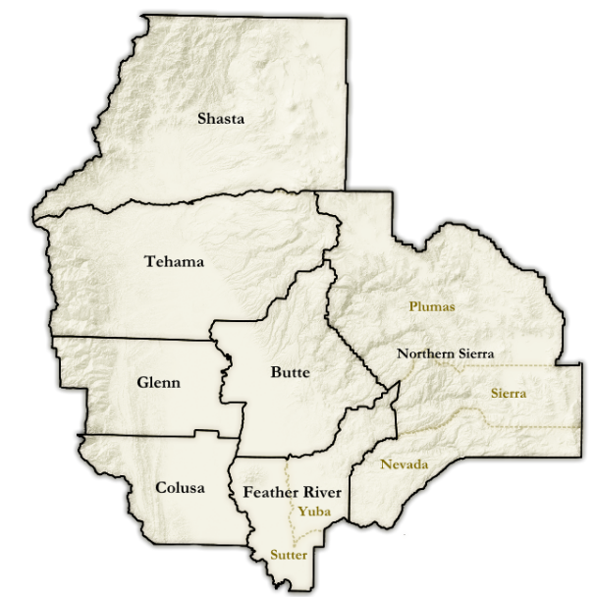
All sections of the Voucher Application Form must be completed. A copy should be retained by the Applicant for their records. The voucher program is not responsible for materials lost by mail. Please review the program terms prior to signing below. Submit your completed application with attachments by email, mail, or hand delivery to the Air District for the county in which the home with the device is located.
County | Air District | Mailing Address | City, ZIP | Email
Butte | Butte County AQMD | 629 Entler Avenue #15 | Chico, 95928 | jmandly@bcaqmd.org
Colusa | Colusa County APCD | 100 Sunrise Blvd. #F | Colusa, 95932 | cryan@countyofcolusa.com
Glenn | Glenn County APCD | 720 N Colusa Street | Willows, 95988 | asmith@countyofglenn.net
Nevada | Northern Sierra AQMD | 200 Litton Drive #320 | Grass Valley, 95945 | saml@myairdistrict.com
Plumas | Northern Sierra AQMD | 200 Litton Drive #320 | Grass Valley, 95945 | saml@myairdistrict.com
Shasta | Shasta County AQMD | 1855 Placer Street Suite 101 | Redding, 96001 | airquality@co.shasta.ca.us
Sierra | Northern Sierra AQMD | 200 Litton Drive #320 | Grass Valley, 95945 | saml@myairdistrict.com
Sutter | Feather River AQMD | 541 Washington Avenue | Yuba City, 95991 | fraqmd@fraqmd.org
Tehama | Tehama County | 1834 Walnut Street | Red Bluff, 96080 | lmann@tehcoapcd.net
Yuba | Feather River AQMD | 541 Washington Avenue | Yuba City, 95991 | fraqmd@fraqmd.org

Personal information given to the district is done so voluntarily and will only be used to verify or validate eligibility for the Woodsmoke Reduction Program. Documents containing personal information to demonstrate low-income eligibility should either be hand delivered or mailed to the Air District. After eligibility has been determined, such documentation will be returned or destroyed. The District cannot guarantee the security of personal information transmitted by e-mail, fax or delivered through a third party.

VOUCHER APPLICATION FORM
Applicant Information:
___________________________________________________________________________
Name

________________________________________________________________________________________
Physical Address City State Zip Code

Primary Residence Long-term Rental Other ___________________________

________________________________________________________________________________________
Mailing Address (if different) City State Zip Code

Phone Number: ___________________________ Email (if available): _______________________________

Existing Wood Burning Device:

Make/Model: __________________________________ Year Manufactured/Age: ____________________

- I have included a photograph of my old device to be replaced

My old device is (check one): Non-certified freestanding woodstove
Non-certified woodstove insert
Open hearth fireplace (please include photo of wood-storage area)

New Device to be installed (check one): EPA certified* wood-burning stove / insert
EPA certified* pellet stove / insert
Electric stove heater
Electric heat pump

* After May 15, 2020, new EPA certified wood and pellet stove / inserts must meet Step 2 standards with a 2.0 grams per hour emissions rate. Only a limited number of non-catalytic woodstoves are available. Participating Retailers will assist with offering compliant devices.

Incentive Level:
Standard Incentive: $2,500 for new pellet, wood-burning, and electric stove devices or $5,000 for new electric heat pump installations.
Enhanced Incentive: up to $5,000 for new pellet, wood-burning, and electric stove devices or $10,000 for new electric heat pump installations (indicate qualification below – back-up documentation required).
Located in a Low Income or Disadvantaged Community (see link to map on page 1)
Proof of participation in a federal or state income assistance program (WIC, CARE, LIHEAP)
Household income less than $67,277 annually

Additional Information

1. In a typical heating season, how many cords of wood do you typically burn? _________

2. Is your current device used as a primary source of heat (>50% winter use) Yes No

APPLICANT CERTIFICATION:

I certify the following:

a. I understand that only a currently installed and operating non-EPA certified wood burning devices used as a primary source of heat is eligible to be replaced under this program.
b. I understand that participants are limited to receiving one (1) rebate per address.
c. I understand that applications are processed in the order they are received. Rebates will be distributed on a first-come, first-served bases. Funding is limited; rebates are not guaranteed. The voucher will only be valid for four (4) weeks from the date of issuance. No retroactive rebates are available. Voucher expiration date may be extended at the discretion of the District.
d. I understand that applications may only be accepted for devices located in Butte, Colusa, Glenn, Nevada, Plumas, Shasta, Sierra, Sutter, Tehama, and Yuba counties in California.
e. I understand that if I qualify, I will receive a voucher and a current list of Participating Retailers who will honor the voucher if it is submitted by the expiration date written on the voucher.
f. The participating retailer who installs the new device is responsible for properly dismantling and disposing of the old device.
g. If I choose to replace a device with funds from this program, I will make a commitment to purchase a device from a Participating Retailer within the four (4) week period and authorize the retailer to forward to the District a notification of the purchase agreement, with verification that my existing wood burning device is not EPA-certified.
h. I understand that devices purchased with funds from this program will be professionally installed by a licensed installer and that there may be additional costs for installation including a permit from my community for installation. Installations must comply with all local fire and building codes. The installation must be coordinated and certified by the Participating Retailer and must be completed within ninety (90) days of redeeming the voucher. Installation expiration date may be extended at the discretion of the District.
i. I understand that I am responsible to pay the retailer for the purchase price of my new device, less the voucher amount. I also understand that I am responsible for paying for any upgrades beyond a safe, basic model.
j. I understand that I will forfeit my voucher if I provide the District with false information or fail to obtain any required permit or if the required information is not submitted to the District prior to the expiration date listed on the voucher.
k. The District does not warranty any devices purchased under this voucher program, including, but not limited to, the quality or functionality of the device.
l. I understand proper wood burning practices (e.g. burning only dry, seasoned wood) and proper stove installation and operation (e.g. maintaining a hot fire) are critical to the effectiveness of my new device. I further agree to receive training on proper wood storage and wood burning practices (if applicable) and device operation and maintenance from the Participating Retailer or Installer.
m. I understand that the District and the State of California may inspect all work and associated records with 30-day advanced notice.
n. Applications will be treated in accordance with Public Records Act requirements. Certain information, subject to those requirements, may be publicly disclosed.

Applicant Name (Print): _______________________________________ Owner Tenant
Owner of Rental Property

Applicant/Owner Signature: _______________________________________________________

Date: ____________________

